**Challenge:1**

**Customer Service**

**Objective**

To enhance the customer service experience by leveraging generative AI technologies to provide personalized, efficient, and proactive support across multiple channels.

**Challenge**

* Automate customer inquiries and provide accurate responses in real-time.
* Offer personalized recommendations and solutions based on customer data and interaction history.
* Seamlessly integrate with existing customer service platforms and maintain a high level of security and data privacy.

**Solution:**

Bank of Baroda Copilot: AI-Powered Multi-Channel Customer Service Chatbot

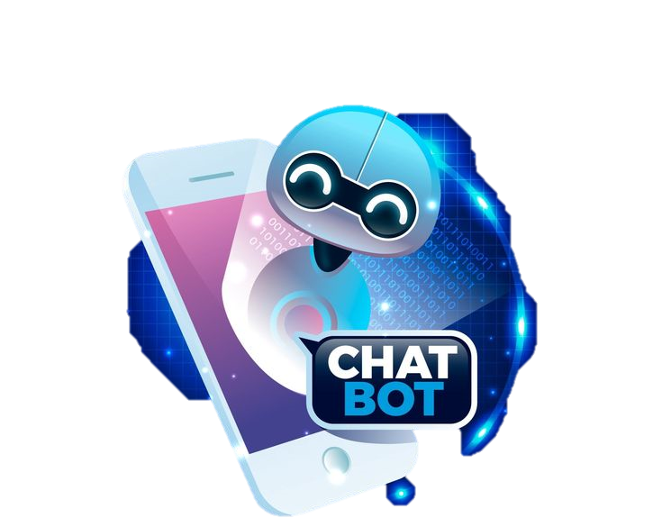

**Multi-Channel Chatbot Solution for Bank of Baroda:**

**Documentation**

**1. Introduction**

**1.1 Overview**

This documentation outlines the implementation of a multi-channel chatbot solution for Bank of Baroda, leveraging Microsoft Copilot Studio and Azure Bot Service. The solution aims to enhance customer interaction by automating routine inquiries, providing personalized recommendations, and offering proactive support through various communication channels.

**1.2 Objectives**

* Improve customer experience with personalized interactions.
* Automate routine inquiries to increase efficiency.
* Offer proactive support to enhance user engagement.
* Ensure scalability and security for robust growth.

**2. Solution Architecture**

**2.1 Secure, Cloud-Based Architecture**

The chatbot is built on Microsoft Azure, providing a secure and scalable infrastructure. Key components include:

**Microsoft Copilot Studio:** Hosts the chatbot logic, conversation flows, and AI integrations.

**Azure Cognitive Services:** Includes Language Understanding (LUIS) for NLP, QnA Maker for FAQs, and optional Text Analytics for sentiment analysis.

**Azure App Service:** Hosts and deploys the chatbot application.

**Azure Monitor:** Monitors the performance and health of the chatbot.

**Azure Active Directory** (Optional): Provides secure user authentication and access control if needed.

**2.2 Client Applications**

Bank of Baroda's website, mobile app, and other communication channels interact with the chatbot via APIs, ensuring seamless integration and consistent user experience across platforms.

**3. Methodology**

**3.1 Data Acquisition and Analysis**

Data Sources: Customer interaction logs, FAQs, product information, and user feedback.

Analysis: Identify common queries, user intents, and interaction patterns to train the AI models.

**3.2 Chatbot Design and Development**

Conversation Flows: Design user-friendly conversation flows that guide users through various tasks.

Natural Language Processing (NLP): Utilize LUIS for understanding user intents and entities.

Development: Implement the chatbot logic using Microsoft Copilot Studio and deploy on Azure App Service.

**3.3 Personalization and Proactive Support**

Personalization: Use customer data to provide personalized recommendations and responses.

Proactive Support: Implement triggers for proactive engagement, such as reminders for bill payments or new product announcements.

The Copilot, trained on customer data and interaction history, can offer personalized recommendations for products, investments, or financial advice in the user's preferred language.

**3.4 Conversational Interface:**

Natural Language Interactions: The Copilot utilizes a conversational interface, allowing for natural language interactions in multiple languages. Ask questions, receive clarifications, and get information just by talking, just like you would with a human representative, regardless of your preferred language.

Convenience and Accessibility:

24/7 Availability: Ask whenever you want. The chatbot is available 24/7, addressing customer inquiries or requests anytime, even outside of regular banking hours. This is ideal for busy schedules or time zone differences.

Overall impact: This shift from static interactions to a dynamic and personalized approach can significantly enhance customer satisfaction and brand loyalty. Imagine a customer service experience that feels helpful, informative, and tailored to your specific needs, all delivered in your native language. By leveraging multilingual capabilities, Bank of Baroda can foster a truly inclusive and global banking experience.

**4. Security and Integration**

**4.1 Secure Architecture**

Data Encryption: Ensure all data transmitted between the chatbot and users is encrypted.

Access Control: Utilize Azure Active Directory for secure user authentication and role-based access control.

**4.2 Integration**

API Integration: Ensure seamless integration with Bank of Baroda's existing systems via secure APIs.

Third-Party Services: Integrate with third-party services like payment gateways and CRM systems as needed.

**5. Scalability**

**5.1 Cloud-Based Infrastructure**

Scalability: Utilize Azure's cloud infrastructure to handle increased traffic and ensure high availability.

Microservices Architecture: Design the chatbot with a microservices architecture for modular scaling.

**5.2 Performance Monitoring**

Azure Monitor: Continuously monitor the performance and health of the chatbot, ensuring optimal operation and quick resolution of any issues.

**6. Benefits**

**6.1 Improved Customer Experience**

Personalized Interactions: Provide tailored responses and recommendations based on user data.

Proactive Support: Engage users with timely reminders and updates, enhancing their experience.

**6.2 Increased Efficiency**

Automation: Automate routine inquiries, reducing the workload on customer support teams and improving response times.

**6.3 Data-Driven Insights**

Insights for Development: Use interaction data to identify trends and opportunities for product development and marketing.

**6.4 Scalability and Security**

Growth: Ensure the solution can scale with the growing needs of Bank of Baroda.

Security: Leverage robust security measures provided by Microsoft Azure to protect user data.

**7. Miscellaneous Questions**

**How is your solution better than alternatives and how do you plan to build adoption?**

Competitive Advantage:

Seamless Microsoft Integration: Our solution leverages Microsoft Copilot Studio, which integrates flawlessly with existing Microsoft products like Power Platform and Dynamics 365. This could significantly reduce development time for Bank of Baroda if they're already invested in the Microsoft ecosystem.

Focus on Generative AI: Compared to alternatives that might offer basic chatbot functionalities, our solution prioritizes generative AI. This empowers Copilot Studio to create natural, engaging conversations and offer a more human-like customer service experience.

Built-in Security: Microsoft Azure's robust security features ensure data privacy compliance and secure customer interactions, addressing a critical concern for banks.

Building Adoption:

Pilot Program: We propose a pilot program where the Copilot is initially deployed in a limited capacity, focusing on specific customer segments or product inquiries. This allows for gathering user feedback, refining the solution, and demonstrating its value before a wider rollout.

Employee Training: Providing comprehensive training for Bank of Baroda's customer service staff is crucial. This training should cover using the Copilot, understanding its capabilities and limitations, and effectively integrating it into the customer service workflow.

Data-Driven Optimization: Continuously monitor user interactions with the Copilot and leverage data analytics to identify areas for improvement. This data-driven approach ensures the solution adapts to user needs and delivers long-term value. Internal Communication: We'll work collaboratively with Bank of Baroda to develop a comprehensive internal communication plan. This plan will educate employees about the Copilot's benefits, address any potential concerns, and foster a culture of adoption within the organization.

**Measures incorporated to ensure the security and integrity of your solution**

1. Leverage Built-in Azure Security:

Microsoft Azure: The platform offers robust security features to safeguard data privacy and comply with regulations. These features include:

Encryption of data at rest and in transit to prevent unauthorized access.

Multi-factor authentication for secure logins and access control.

Regular security updates and vulnerability patching to minimize security risks.

2. Secure Data Management:

Customer Data Privacy: The solution prioritizes adherence to data privacy regulations like GDPR and CCPA. This involves transparent data collection practices and user consent for data usage.

Data Minimization: The Copilot is designed to collect only the data necessary for effective customer service interactions, minimizing the amount of sensitive data stored.

3. Secure Chatbot Development:

Microsoft Copilot Studio: This platform offers built-in security features to prevent unauthorized access to the chatbot itself. These features might include access control mechanisms and secure development practices.

Regular Security Audits: The solution should undergo regular security audits to identify and address potential vulnerabilities.

4. Secure Integration:

Seamless Integration: When integrating the Copilot with Bank of Baroda's existing systems, secure protocols and encryption methods should be used to ensure data privacy during communication.

5. User Control and Transparency:

Transparency: Customers should be informed about the use of AI and be given the option to opt-out of interacting with the chatbot and request live agent assistance.

User Control: Customers should have control over their data and be able to access, modify, or delete their chatbot interaction history upon request.

**8. Conclusion**

The multi-channel chatbot solution for Bank of Baroda, built using Microsoft Copilot Studio and Azure Bot Service, offers a secure, scalable, and efficient way to enhance customer interactions. By leveraging generative AI and cloud-based infrastructure, the solution provides personalized and proactive support, improving the overall customer experience while ensuring robust security and scalability.